Assignment 4
Network Threats & Mitigation & Physical Security & Risk

- Create a table listing 5 common network threats (such as phishing, DDoS, man-in-the-middle, malware, and password attacks), and for each, write one real-world example from an app or service you use (like WhatsApp, Instagram, or Paytm).

No. | Network Threat | Real-World Example
1. | Phishing | An Instagram user receives a fake login link designed to steal their password.
2. | DDoS Attack | Attackers flood a shopping website like Flipkart with excessive requests, making it unavailable.
3. | Man-in-the-Middle (MITM) | An attacker on an insecure public Wi-Fi network attempts to intercept a user's unencrypted communication.
4. | Malware | A WhatsApp user downloads a malicious file that infects their device.
5. | Password Attack | An attacker repeatedly guesses a Paytm user's password to try to access their account.

- Simulate a brute-force attack scenario by writing a simple Python script that tries to guess a 4-digit PIN code by checking all possible combinations against a preset value. Constraint: The script should print the number of attempts it took to guess the correct PIN.

- Python Program

# Preset 4-digit PIN
correct_pin = "2584"
attempts = 0

# Try all possible 4-digit combinations
for number in range(10000):
pin = f"{number:04d}"
attempts += 1

if pin == correct_pin:
print("PIN guessed:", pin)
print("Number of attempts:", attempts)
break

- Output

PIN guessed: 2584
Number of attempts: 2585

- Explanation

- The program checks every PIN from 0000 to 9999.
- It increases the attempt counter after each guess.
- When the correct PIN is found, it prints the PIN and total attempts, then stops.

- Result

The program successfully simulates a brute-force attack and calculates how many attempts were needed to guess the correct 4-digit PIN.

- List 4 physical security risks that could affect a server room hosting a popular app like Zomato or BookMyShow, and suggest one mitigation step for each risk.

No. | Physical Security Risk | Mitigation Step
1. | Unauthorized Access: An unauthorized person enters the server room. | Use access cards, biometric locks, and CCTV cameras.
2. | Fire: A fire damages servers and network equipment. | Install smoke detectors and fire-suppression systems.
3. | Power Failure: A power outage shuts down servers. | Use UPS systems and backup generators.
4. | Overheating: High temperatures damage server hardware. | Install proper cooling systems and temperature monitoring.

- List 4 physical security risks that could affect a server room hosting a popular app like Zomato or BookMyShow, and suggest one mitigation step for each risk.

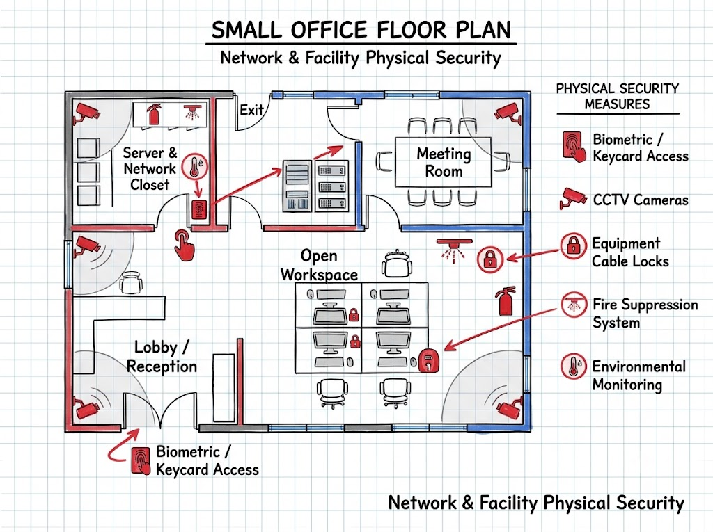

- Biometric / Keycard Access: Installed at the main entrance and the Server & Network Closet to restrict unauthorized entry.
- CCTV Cameras: Strategically placed in corners and critical entrance points—especially facing the Server Closet and main lobby—for continuous visual monitoring.

- Equipment Cable Locks: Securing valuable workstations and server hardware to prevent physical theft.

- Additional Measures: Includes environmental monitoring for Server Room heat control and fire suppression systems (sprinklers/extinguishers) to prevent physical disasters.

- Use ChatGPT or a similar AI tool to generate a checklist of 7 actions a network admin should take to mitigate risks from both network threats and physical security breaches, then review and edit the checklist to make it specific for a college computer lab environment.

1. ☐ Use Firewalls: Configure firewalls to block unauthorized network traffic and suspicious connections.
2. ☐ Install Antivirus: Keep antivirus software updated on all lab computers to protect against malware.
3. ☐ Secure Passwords: Use strong passwords and separate student and administrator accounts.
4. ☐ Control Physical Access: Lock the computer lab when not in use and allow access only to authorized students and staff.
5. ☐ Protect Network Devices: Keep routers, switches, and servers in a locked cabinet to prevent tampering.
6. ☐ Back Up Data: Regularly back up important college files and student project work to a secure location.
7. ☐ Monitor and Update Systems: Install security updates regularly and check system logs for suspicious activities.

Review and Edit: I adapted the checklist for a college computer lab by focusing on student accounts, lab access, network equipment, and student project data.

Result: These seven actions help reduce network threats and physical security risks in a college computer lab.

